Customer Segmentation & Revenue Forecasting Analysis

Using RFM Analysis on Online Retail Data
Author: Sri Pavani
Tools Used: Microsoft Excel, Pivot Tables, Pivot Charts, RFM Analysis, Forecast.ETS
Dataset: Online Retail Dataset
Project Type: Business Analytics / Customer Segmentation

Executive Summary
Customer retention and customer value optimization are critical drivers of business growth. This project analyzes customer transaction data from an online retail company to identify high-value customers, detect churn risks, understand purchasing behavior, and forecast future revenue.
Using RFM (Recency, Frequency, Monetary) analysis, customers were segmented into five actionable groups: Champion, VIP, Loyal, Regular, and At-Risk. The analysis revealed that Loyal and Regular customers make up the majority of the customer base, while a smaller group of Champions and VIPs contribute significantly higher revenue.
The project also included monthly revenue trend analysis and future revenue forecasting using Excel’s ETS forecasting model.

1. Business Problem
The company lacked visibility into customer purchasing behavior and customer value.
Management wanted to answer the following questions:
- Who are the most valuable customers?
- Which customers are likely to stop purchasing?
- How can marketing efforts be prioritized?
- What customer segments should receive special treatment?
- What is the expected revenue trend for the next quarter?
To address these questions, customer segmentation and revenue forecasting were performed using transaction-level sales data.

2. Dataset Overview
The Online Retail dataset contains transactional data from a UK-based online retailer.

Key Fields
- Invoice Number
- Product Description
- Quantity
- Invoice Date
- Unit Price
- Customer ID
- Country

Analysis Period
December 2010 – October 2011

Initial Dataset Size
541,910 transaction records

3. Data Cleaning & Preparation
Data quality issues were identified and resolved before analysis.

Cleaning Activities

Missing Customer IDs
Rows without Customer IDs were removed because customer-level analysis requires unique customer identification.

Invalid Transactions
Records containing incomplete or unusable information were removed.

Date Standardization
The dataset contained mixed date formats.
Examples:
- 01-12-2010 08:26
- 1/13/11 09:23
Dates were standardized into a consistent format to support trend analysis and recency calculations.

Sales Amount Calculation
A new field was created:
Sales Amount = Quantity × Unit Price
This metric represents revenue generated by each transaction.

Final Dataset
- Clean transactions only
- Standardized date fields
- Analysis-ready dataset

4. Feature Engineering
Several new fields were created.

Sales Amount
Measures revenue generated per transaction.

InvoiceDate_Final
Created to standardize mixed date formats.

Month_Start
Created for monthly aggregation and trend analysis.

Customer Metrics
Created customer-level metrics for RFM analysis.

5. RFM Analysis
RFM Analysis is a customer segmentation framework based on:

Recency (R)
Measures how recently a customer made a purchase.
Lower recency values indicate higher customer engagement.

Frequency (F)
Measures how often a customer purchases.
Higher frequency indicates stronger loyalty.

Monetary (M)
Measures total customer spending.
Higher monetary values indicate greater customer value.

6. Customer Segmentation Strategy
Customers were classified into five segments based on RFM metrics.

Champion
Highest-value customers with:
- High spending
- High purchase frequency
- Recent activity
These customers are the company’s most valuable assets.

VIP
Customers with significant spending and strong engagement.
They generate substantial revenue and should receive loyalty-focused treatment.

Loyal
Customers who purchase consistently over time.
They represent a stable revenue source.

Regular
Average customers with moderate activity levels.
These customers represent future growth opportunities.

At-Risk
Customers who have not purchased recently.
These customers require re-engagement efforts to prevent churn.

7. Segment Analysis Results

Customer Distribution
Segment | Count
Champion | 11
VIP | 221
Loyal | 1564
Regular | 1673
At Risk | 870

Key Observation
The majority of customers belong to Loyal and Regular segments, while Champions and VIPs represent a smaller but highly valuable customer base.

8. Dashboard Development
An executive dashboard was developed to summarize customer behavior and business performance.

Dashboard Components
- Total Customers
- Champion Customers
- At-Risk Customers
- Customer Segment Distribution
- Average Customer Value by Segment
- Segment Summary Table
- Monthly Revenue Trend
- Revenue Forecast

Dashboard Objective
Enable business stakeholders to quickly identify opportunities and risks.
Dashboard Screenshot
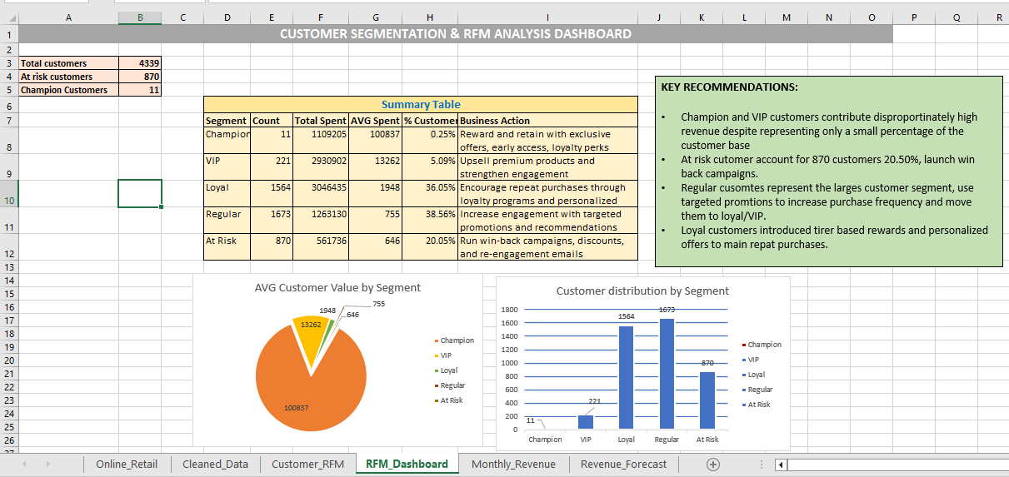

9. Trend Analysis
Monthly sales revenue was analyzed using Pivot Tables and Line Charts.

Findings
- Revenue remained relatively stable throughout the analysis period.
- Peak sales exceeded £900K during high-performing months.
- Revenue fluctuations indicate seasonal purchasing behavior.
- Overall business performance remained healthy.
Trend Chart Screenshot
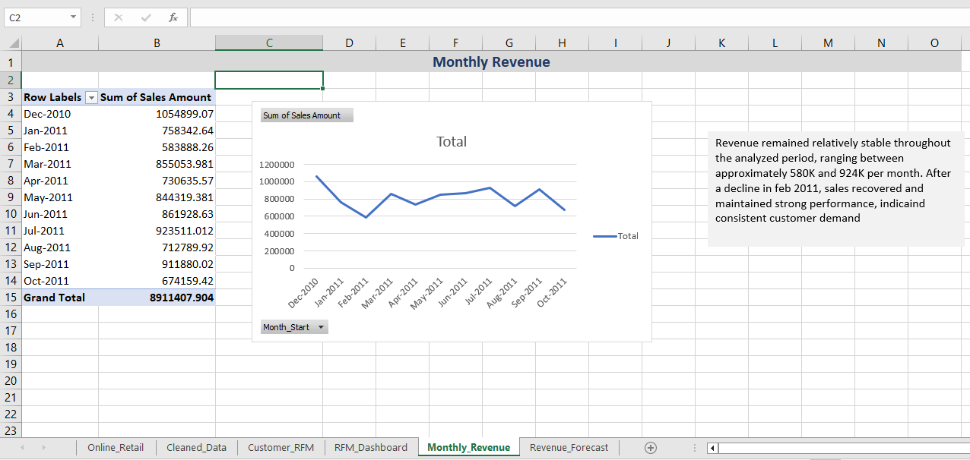

10. Revenue Forecasting
Revenue forecasting was performed using Excel’s Forecast Sheet based on the ETS (Exponential Triple Smoothing) model.

Forecasted Revenue
Month | Forecast Revenue
Nov-2011 | 716,035
Dec-2011 | 709,903
Jan-2012 | 703,770

Interpretation
Revenue is expected to remain stable around £700K per month in the upcoming quarter.
The forecast suggests consistent customer demand and no significant decline in sales performance.
Forecast Screenshot
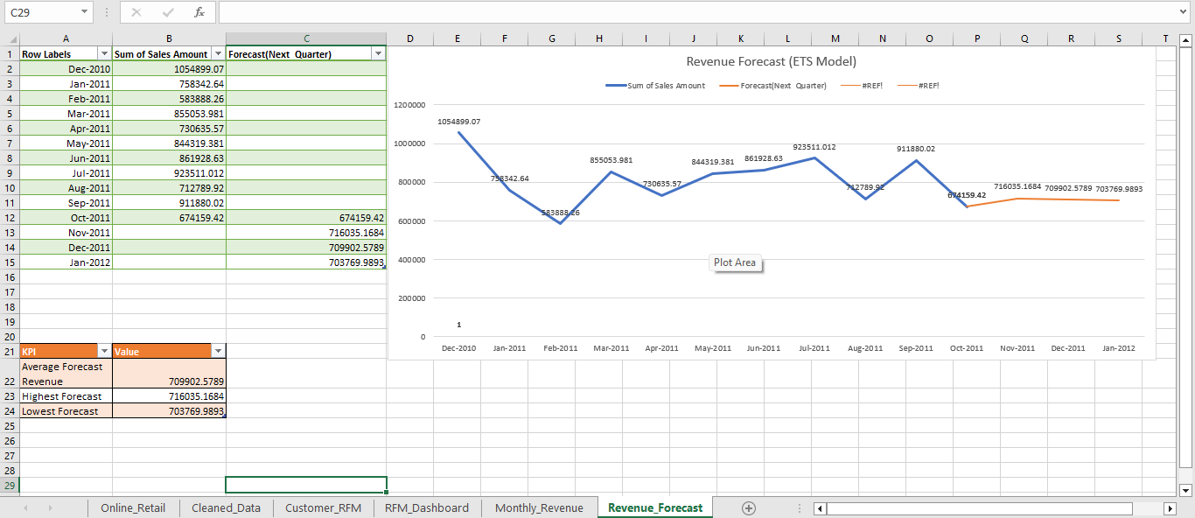

11. Key Business Insights

Insight 1
Loyal customers represent the largest customer segment and provide stable recurring revenue.

Insight 2
Champion and VIP customers contribute disproportionately high value relative to their population size.

Insight 3
870 customers were identified as At-Risk and represent a significant retention opportunity.

Insight 4
Monthly sales trends indicate stable business performance with moderate fluctuations.

Insight 5
Revenue forecasts suggest stable future revenue levels.

12. Business Recommendations

Retain High-Value Customers
Implement exclusive loyalty programs for Champion and VIP customers.

Reduce Churn
Launch targeted win-back campaigns for At-Risk customers.

Increase Customer Lifetime Value
Encourage Regular customers to move into Loyal and VIP segments through personalized promotions.

Improve Customer Engagement
Strengthen communication through newsletters, loyalty rewards, and product recommendations.

Monitor Forecast Trends
Review forecast accuracy monthly and adjust business strategies accordingly.

13. Project Outcome
This project successfully transformed raw transaction data into actionable business insights.
Achievements include:
- Customer segmentation using RFM methodology
- Identification of high-value customers
- Detection of churn-risk customers
- Revenue trend analysis
- Revenue forecasting using ETS
- Executive dashboard creation
The final dashboard provides decision-makers with a practical framework for customer retention, revenue optimization, and strategic planning.

Conclusion
Customer segmentation and predictive analysis enable organizations to better understand customer behavior and allocate resources effectively.
By applying RFM analysis, the company can prioritize high-value customers, reduce customer churn, improve marketing effectiveness, and support future revenue growth through data-driven decision-making.

